Node
Node表示网络拓扑上的一个节点。其命名类似于文件命名：
* For example, a data node's name is hostname:port# and if it's located at
* rack "orange" in datacenter "dog", the string representation of its
* network location is /dog/orange

定义的方法：
- public String getNetworkLocation();
- public void setNetworkLocation(String location);
- public String getName();
- public Node getParent();
- public void setParent(Node parent);
- public int getLevel();
Return this node's level in the tree.
E.g. the root of a tree returns 0 and its children return 1
- public void setLevel(int i);

DatanodeInfo
DatanodeInfo实现了Node，并继承自DatanodeID，表示一个DataNode的状态

属性：
- protected long capacity;
- protected long dfsUsed;
- protected long remaining;
- protected long lastUpdate;
- protected int xceiverCount; /** number of active connections */
- protected String location = NetworkTopology.DEFAULT_RACK; /** rack name **/
- protected String hostName = null;
在datanode注册时，会提供一个自己的名称
- protected AdminStates adminState;
- private int level; //which level of the tree the node resides
- private Node parent; //its parent

方法：
- public long getNonDfsUsed()
返回capacity - dfsUsed - remaining;（即不是被DFS占用的空间）
- public String getHostName()
如果hostName没有记录，则从name中解析，否则直接返回hostName
- public AdminStates getAdminState()
如果adminState为null，则返回AdminStates.NORMAL;，否则返回adminState
- protected void setAdminState(AdminStates newState)
如果传入的newState为AdminStates.NORMAL)，则设置adminState为null，否则设置adminState = newState;

AdminStates
枚举：
NORMAL, DECOMMISSION_INPROGRESS, DECOMMISSIONED;

DatanodeDescriptor
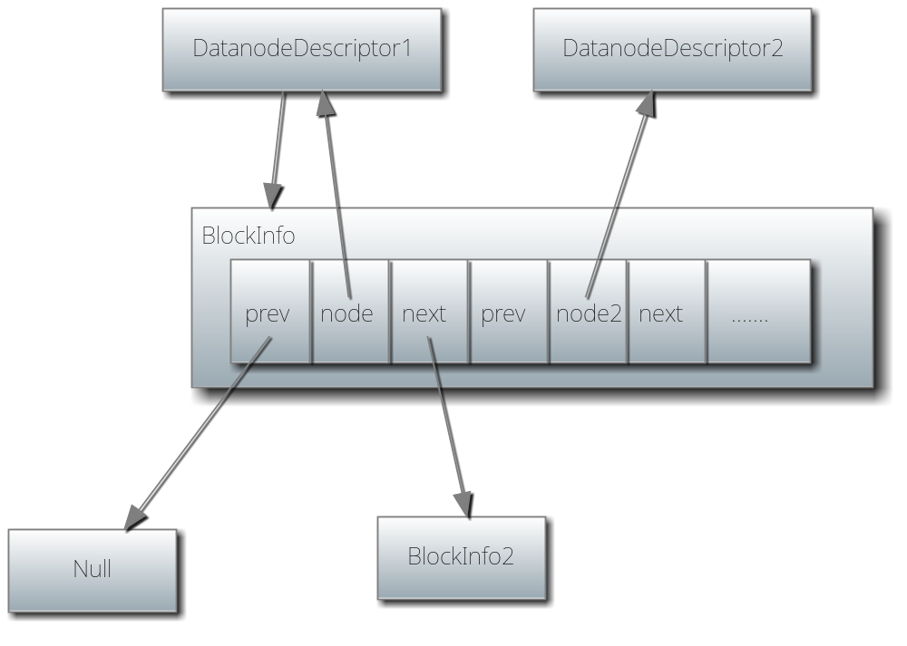
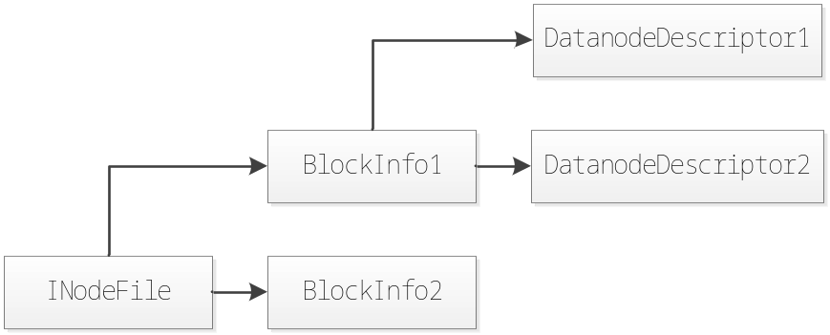

继承自DatanodeInfo，除了DatanodeInfo中保存的信息外，还保存了存储在这个datanode上的block信息。

由上图可以看出，DatanodeDescriptor只持有了一个BlockInfo，但是用过这个BlockInfo内部的数组，可以查找下一个block，即图中的BlockInfo2。

而BlockInfo中维护了储存这个block的所有datanode的信息。

属性：
- private volatile BlockInfo blockList = null;
- protected boolean isAlive = false; // isAlive == heartbeats.contains(this)
- protected boolean needKeyUpdate = false;
- private long bandwidth;
当调用dfsadmin -setBalanacerBandwidth <newbandwidth>设置带宽时会设置这个值
- private BlockQueue replicateBlocks = new BlockQueue();
A queue of blocks to be replicated by this datanode
- private BlockQueue recoverBlocks = new BlockQueue();
A queue of blocks to be recovered by this datanode
- private Set<Block> invalidateBlocks = new TreeSet<Block>();
A set of blocks to be invalidated by this datanode
- private int currApproxBlocksScheduled = 0;
- private int prevApproxBlocksScheduled = 0;
- private long lastBlocksScheduledRollTime = 0;
8-10为：Variables for maintaning number of blocks scheduled to be written to this datanode，其中8，9为约值
- private static final int BLOCKS_SCHEDULED_ROLL_INTERVAL = 600*1000; //10min
- private boolean firstBlockReport = true;
Set to false after processing first block report

方法：
- boolean addBlock(BlockInfo b)
  - 调用b.addNode(this)，先把node添加到block中去
  - 再把b作为node的block头部blockList = b.listInsert(blockList, this);
  - 注意，调用结束后，blockList就指向新插入的b，因为每次都是插到最前端，具体实现参考BlockInfo。所以blockList始终都是该datanode中存储的blcok列表的head
- boolean removeBlock(BlockInfo b)
  - 先调用blockList = b.listRemove(blockList, this);
  - 在删除b.removeNode(this);
  - 和1相反，先把该blcok从该datanode的block列表中删除，然后再从block的datandoe列表中删除该node
- void moveBlockToHead(BlockInfo b)
先删除再插入
- void resetBlocks()
清空所有
- public int numBlocks()
调用blockList.listCount(this)，即遍历整个链表
- void updateHeartbeat(long capacity, long dfsUsed, long remaining, int xceiverCount)
设置一些属性，然后调用rollBlocksScheduled(lastUpdate);
- BlockCommand getReplicationCommand(int maxTransfers)
  - 查询出List<BlockTargetPair> blocktargetlist = replicateBlocks.poll(maxTransfers);
  - 返回new BlockCommand(DatanodeProtocol.DNA_TRANSFER, blocktargetlist);
- void reportDiff(BlocksMap blocksMap, BlockListAsLongs newReport, Collection<Block> toAdd, Collection<Block> toRemove, Collection<Block> toInvalidate)
根据newReport计算出差异，结果放到三个列表中。
- public int getBlocksScheduled()
currApproxBlocksScheduled + prevApproxBlocksScheduled;
- private void rollBlocksScheduled(long now)
如果从上次调用此方法开始计时，已经过了10分钟，则可以再次调用：
- 设置prevApproxBlocksScheduled = currApproxBlocksScheduled;
- 设置currApproxBlocksScheduled = 0;
- 设置lastBlocksScheduledRollTime = now;

BlockIterator
负责遍历datanode上的block，实现了Iterator<Block>

属性
- private BlockInfo current;
- private DatanodeDescriptor node;

方法
- public boolean hasNext()
若current != null则返回true
- public BlockInfo next()
返回current，然后设置current = current.getNext(current.findDatanode(node));
- public void remove()
不支持！！

BlockTargetPair
存储blcok到datanode的映射

属性：
- public final Block block;
- public final DatanodeDescriptor[] targets;

BlockQueue
存储BlockTargetPair的队列

属性：
private final Queue<BlockTargetPair> blockq = new LinkedList<BlockTargetPair>();

方法：
- synchronized boolean offer(Block block, DatanodeDescriptor[] targets)
添加到queue：blockq.offer(new BlockTargetPair(block, targets));
- synchronized List<BlockTargetPair> poll(int numBlocks)
从queue中取出numBlocks个BlockTargetPair

DecommissioningStatus
属性：
- int underReplicatedBlocks;
- int decommissionOnlyReplicas;
- int underReplicatedInOpenFiles;
- long startTime;

DatanodeID
DatanodeID是datanode name和storage id的组合表示

属性：
- public String name; /// hostname:portNumber
- public String storageID; /// unique per cluster storageID
- protected int infoPort; /// the port where the infoserver is running
- public int ipcPort; /// the port where the ipc server is running

方法：
public int getPort()
默认返回50010

